ANNUAL REPORT 2022-23
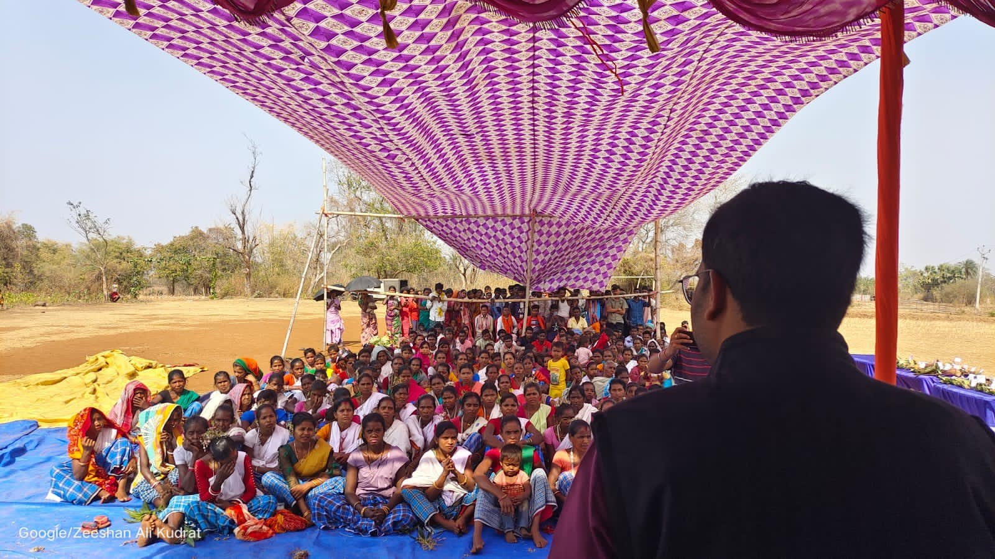
LOKDEEP
College Road, Madhupur, 815353
District-Deoghar, Jharkhand,India
Mobile No.-9431132968
E-mail-lokdeeporg@gmail.com

FORE WORDS
This annual report is not only a record of achievement for us, but also each work completed is associated in our memory with faces to which we brought smiles. In Raneshwar block of Dumka major activities are related with women empowerment and micro finance, in Devipur block of Deoghar on RCH and safe motherhood, in Narayanpur block of Jamtara on local governance, Panchayati Raj institutions and in Madhupur block of Deoghar on Natural resource management.
Social Mobilization is the key Component of LOKDEEP. Through the action LOKDEEP wants to establish a permanent forum of the people at village level for planning, execution and monitoring its development programs for a longer period. This basic strategy enforces to sustain the program.
This year we have been able to further strengthen our micro-finance program and increase the participation of women in development process.However, the organization has faced paucity of funds and needs additional support from donors and development agencies.

We would like to thank our donor organizations for their full support in our endeavor. We express our sincere thanks to the volunteers, local community and associated local experts who helped the organization to serve in a better way. Last but not least I would like to thank the Lok Deep project and office staff, advisors and members of the Governing body for their devoted attention to guide our team members from time to time especially in the critical situations. We are also grateful to SPWD, Ranchi, Abhivyakti Foundation, Giridih and individual Consultants for their technical support and cooperation.
Please feel free to express your opinion and suggestions to improve our efforts.
Let us join hands together.

Pradip Kumar Singh
Director

Madhupur,30.07.2023

Name of the Organization | Lokdeep
Address | College Road, Madhupur  District Deoghar, PIN – 815353
Legal Status | Registered Under Socities Registration Act 1860(Act XXII)with Govt. Of Jharkhand.  Registration No. REGd.-342 dated 21st July.12A of Income Tax Act,1961.  Regd.Under FCRA, 1976.
Contact person | Mr.Pradip Kumar Singh
Registered Address: | Collage Road Madhupur, district- Deoghar  Jharkhand, India
Our Bankers | Allahabad Bank, Madhupur  Deoghar.

Background Information
The organization emerged as devolutionary concept to localize the development initiatives. In 1987 construction of Burhai dam some social organizations came forward where the founders of Lok Deep joined the movement and further participated in the mass campaigns for community based natural resource management. In the process we came in contact with Late Binay Chandra Singh, an ex-Army,a renowned social worker and environmentalist of the area who motivated the team for social work. The founders were taking up full-fledged activities. The devolutionary approach of Badlao encouraged key leaders to take up own initiatives in the area from where the organization came into existence.

Our Mission
We are committed to establish effective and mutually beneficial partnerships among NGOS, farmer organizations and agricultural research centers in order to mobilize research to benefit the rural poor in less favorable environments for social justice, sustainable development and human rights. We are also committed to the dissemination of information and promotion of sustainable development initiatives, in response to the needs of underrepresented and marginalized sectors of society.
Lok Deep, is an organization which fully believes in all around development of the areas. Specific role of Lok Deep in rural development are as follows:
* To supplement government effort
* To mobilize and sensitize the people at the village level.
* To set an example to activate the delivery system.
* To disseminate information to make communities as self- reliant as possible
* To show how village and indigenous resources could be used.
* To train of community leader and Local resource person.
* To mobilize local financial resources, and
* To mobilize and organize the poor.

Values / guiding principles
Democratic process, team work, transparency, accountability and social responsibility are the guiding principles of Lok Deep.
We believe that community has the power to address its own problems and someone has to take initiatives to trigger off. Poverty comes from the social stigmas and the community has power to overcome poverty where organization, govt. and other agencies could facilitate the development process. Undemanded aids without involving the local communities’ causemuch dependency on external sources whereas Lok Deep has specific focus to build up local resources and further develop the social regulations to strengthen the development process.
Philosophy of Development
The development philosophy of Lok Deep is based on Maxim “your problems; your solution” to encourage self-help approach among disadvantaged community. To enable the decision-making abilities among these venerable communities the organization follows a systematic path approach:
- Community organization
- Capacity building
- Facilitation for technical, financial and marketing linkages & information sharing.
- Establishment of pilot models & replication
- Policy advocacy

Major Initiatives of Lokdeep during the period 2022-23
Women Day celebration at Birajpur Panchayat.
In a remarkable event organized by our NGO in the Birajpur Panchayat of Karmatar Block, we celebrated Women's Day with fervor and enthusiasm. The event witnessed active participation from all communities' members including women and girls, marking a significant step towards promoting gender equality and empowerment.
Key Objectives:
- Promoting Gender Equality Through Sports.
- Recognition of Women's Talents and Achievements.
- Fostering Community Bonds.
- Empowering Through Recognition.
- Creating a Positive and Inclusive Environment.
The heart of the celebration was a series of football games arranged exclusively for the participating women and girls. The games provided a platform for participants to showcase their talents and foster a sense of camaraderie.
Recognition of achievements is a key element in fostering motivation and confidence. As part of the celebration, a prize distribution ceremony was held to honor outstanding performances during the football games. Trophies, medals, and certificates were awarded to participants, acknowledging their dedication and sportsmanship

The event was not only a celebration within the NGO but also a community-wide effort. The active participation of local residents, leaders, and volunteers underscored the collective commitment to advancing gender equality. It served as a platform for open discussions on the challenges faced by women in the community and strategies to address them collaboratively.

The day concluded with a gesture of appreciation – refreshments provided to all participants. This moment allowed for informal interactions, providing an opportunity to strengthen social bonds and reinforce the sense of community among the women and girls.

Impact:

- 120 girls and women participated in the women's day celebration.

- Participants experienced heightened levels of self-confidence and empowerment through active engagement in sports and recognition of their talents.

- Strengthened community unity and cohesion, with increased awareness and collective efforts towards challenging gender stereotypes.

- Established positive role models within the community, inspiring women and girls to pursue their passions and aspirations.
- Recognition of diverse skills and talents, contributing to a more inclusive and appreciative community atmosphere.

Identification of Malnourished Children for Jeev Daya Project Planning
For applying the project to Jiv Daya foundation, Lokdeep undertook a crucial initiative to identify malnourished children in the villages of Kalajharia, Shakalpur, and Shahrjori within the Burmundi Panchayat. The focus was on communities belonging to Particularly Vulnerable Tribes, Scheduled Castes, and Scheduled Tribes. Through household surveys and the measurement of Body Mass Index (BMI), Lokdeep aimed to pinpoint children in need of urgent nutritional, educational, and healthcare interventions.
Objectives:
- Identification of Malnutrition child between age between 6 months to 6 years.
- Enhancing Well-being and Education
- Nutrition and Education Promotion

Process:
  - Lok Deep conducted comprehensive household surveys in Kalajharia, Shakalpur, and Shahrjori villages to identify malnourished children.
  - The Body Mass Index (BMI) of children from Particularly Vulnerable Tribes, Scheduled Castes, and Scheduled Tribes was measured to assess their nutritional status accurately.
  - Through rigorous assessment, Lok Deep identified 100 malnourished children in need of immediate assistance.
Impact:
  - We identified 100 malnourished children in Kalajharia,Shakalpur, and Shahrjori villages.
  - Then we submitted the project to Jiv Daya foundation and it got sanctioned.In the coming year we will work on this project.

Health Awareness Campaign in Karmatar Block:
Lok Deep organized a health awareness campaign. Vitamin Angel, an organization from the USA, provide essential medicines and supplements to Lok Deep. We conducted interactive workshops and did health check-ups and for finding the people with worming and Vitamin A deficiency. This initiative aimed at addressing common health issues among children and women, promoting overall well-being.

Key Objectives:

Our primary objective in organizing the health awareness campaign was to educate and inform the community about the importance of primary health services. By raising awareness, we aimed to empower individuals to make informed decisions about their health, access available services, and promote a proactive approach to well-being.
This activity Increased awareness about the significance of regular health check-ups and preventive care.Improved understanding among the community about the benefits of primary health services.Direct health benefits to 5000 children and 300 women through deworming tablets and Vitamin A supplements.
Special Coaching Center for Boys and Girls
- Lokdeep established the coaching centre in Patrudih village,Posta panchayat Jamtara for the students of marginalized class who don’t get the opportunity to study due to some financial issues. The center is designed to be self-reliant, driven by active community participation, aiming to bridge educational gaps, empower students, and foster an environment conducive to holistic learning. 30-35 students are there studying in the coaching centre.
Key Objectives:
- Providing Quality Education: The center is dedicated to offering high-quality education to students facing financial constraints, ensuring they receive the same opportunities as their more privileged peers.
- Bridging Educational Gaps: Our objective is to bridge educational disparities by providing additional support and resources to students, enabling them to thrive in the mainstream education system.
- Promoting Community Participation: We aim to actively involve the community in the education of their children, fostering a sense of ownership and shared responsibility for the students' academic journey.
- Empowering Students: Beyond academics, the coaching center seeks to empower students by imparting skills, building confidence, and enhancing overall personality traits to help them overcome socio-economic challenges.
- Holistic Learning Environment: We strive to create an environment conducive to holistic learning, going beyond traditional teaching methods to support the overall development of students.

Impact:
This activity Increased community involvement and participation in the education of their children. Witnessed positive changes in students' confidence, communication skills, and overall personality development. Demonstrated a significant improvement in the academic performance of students attending the coaching center.
Prevention of Child Marriage.
Lok Deep is a state level active member of Girls Not Brides organization.They are working to address the critical issue of child marriage in Birajpur panchayat in Jamtara district.This partnership aims to contribute to the prevention of child marriages and the overall enhancement of child protection within the community.We organize adolescent girls meeting and create awareness among them.
Key Objectives
- Raising Awareness:
Increase awareness about the negative impacts of child marriage within the community.
- Strengthening Child Protection Community:
Enhance the capacity of the child protection community to identify, prevent, and respond to cases of child marriage.
- Reducing Incidence of Child Marriage:
Achieve a measurable reduction in the number of reported cases of child marriage within the community.
- Empowering Girls:
Enable girls to access education and skill development opportunities, leading to increased confidence and independence.
- Community Vigilance and Protection:
Strengthen child protection mechanisms within the community.

Impact :
  - 5 Adolescent club was formed at Panchayat level.
  - Notable reduction in reported cases, indicating successful prevention efforts.
  - Increased awareness resulting in a positive shift in community attitudes towards early marriages.
  - Girls gaining access to education and skill development opportunities, fostering confidence and independence.
  - Positive changes in societal perceptions about the role and potential of girls.

Advancing agricultural practices among small and marginalized farmers in the Birajpur Panchayat.

Key Objectives:
- Seed Distribution: Facilitating the distribution of high-quality seeds for paddy, maize, and other vegetables to 50 small and marginalized farming households in the region.
- Nursery Raising: Implementing effective techniques for nursery bed preparation to enhance seedling quality and promote robust crop growth.
- In-Class Training: Conducting a comprehensive training program, consisting of a one-day classroom session followed by five days of farm demonstrations and practical in-field training.

Lokdeep collaborated with local suppliers to source quality seeds, organized distribution events, and ensured equitable allocation to farmers in need.Provided step-by-step guidance on nursery bed preparation, offering hands-on assistance to farmers and addressing any challenges encountered.Engaged agricultural experts to conduct informative classroom sessions, followed by immersive farm demonstrations and on-site training to reinforce theoretical knowledge.

Impact:
- Enhanced Farming Practices: The adoption of improved agricultural practices by 50 small and marginalized farmers has resulted in more efficient and sustainable farming methods.
- Food Security: The increased yield and improved crop quality have contributed to enhanced food security in the Birajpur Panchayat, ensuring a more stable and reliable food supply for the community.
- Income Enhancement: The implementation of advanced techniques has led to increased productivity, subsequently boosting the income of participating farmers and contributing to economic upliftment in the region.
In summary, our annual agricultural development initiative has not only met its objectives but has also left a lasting positive impact on the livelihoods of the farmers and the overall agricultural landscape in the Birajpur Panchayat.

Women Empowerment through Self Help Approach
Lok Deep believes that community empowerment with rights-based approach leads to sustainable development. Therefore, we emphasize to make community rich in information through our community educative program, so that they could address their social poverty, initiate for their economic upliftment and realize their civic rights with integrated development approach. Our community empowerment program is much more focused on Dalit and most backward women. Under this program sector, we focus on the following components:
- Formation of informal community institutions (women SHGs, SHG- based federations at Gram Panchayat level and confederation at block level)
- Capacity building of community institutions in area of CBO management, community leadership promotion and issue specific topics
- Establishing coordination between community and frontline govt. machinery for smooth and fair realization of rights & entitlements
- Special emphasis on women empowerment and advocacy and lobbying on women issues
Key objectives
- To organize and empower poor people with special focus on women.
- To enable poor for realizing their entitlements and rights
- To build the capacity of community-based organizations (CBOs) for innovation and sustainability in community empowerment, poverty, alleviation and development.
Capacity building
The following activities were implemented in field of order to achieve the objectives:
- SHG promotion and their capacity building through monthly meetings, cluster meetings and need based trainings
- Formation of SHG-based federations and their capacity building through meeting, orientation and training
- Training of federations on advocacy tools
- Capacity building orientations, trainings and workshops of field level staff
- Orientation meetings on gender-based issue & their development
- Camps on govt. social security schemes
- Facilitating SHGs and federations for realizing the entitlements through organized initiatives
- Forming Group of Adolescent Girls and their sensitization towards gender, education and their rights

CAMPEIGN TO END THE VIOLENCE AGAINST WOMEN
Lok Deep is an active member of JUMAV MANCH, a state level networking of civil society organizations working on the issue violence against women. In Jamtara district Lok Deep has promoted 10 pressure groups of women to advocate on women’s right and safeguard their interests. The groups have settled more than 14 cases during the year and local women often seek their help in nearby areas for guidance and moral support to fight for their rights and interests. Local awareness activities, rallies, demonstration activities have caught immediate action of the local administration on the cases of violence against women brought to their notice.

FUTURE PRIORITIES
- Strengthening Village level Education Committee and Education for SC/ST and OBC children in remote tribal/rural areas by opening Residential/Non-Residential schools and informal centers like Child Support Centers and Promoting Community based Rehabilitation of Destitute and Disadvantaged people especially women of economically and socially backward front.
- Socio economic Empowerment of women through the process of Self-Help Groups and development their managerial capacity and skill for income generation and federate them as micro finance institution at block and district level.
- Reconstruct rural infrastructure and to initiate action research for effective and maximum utilization of community resource by the people on a sustainable basis.
PHOTO GALLERY

 | 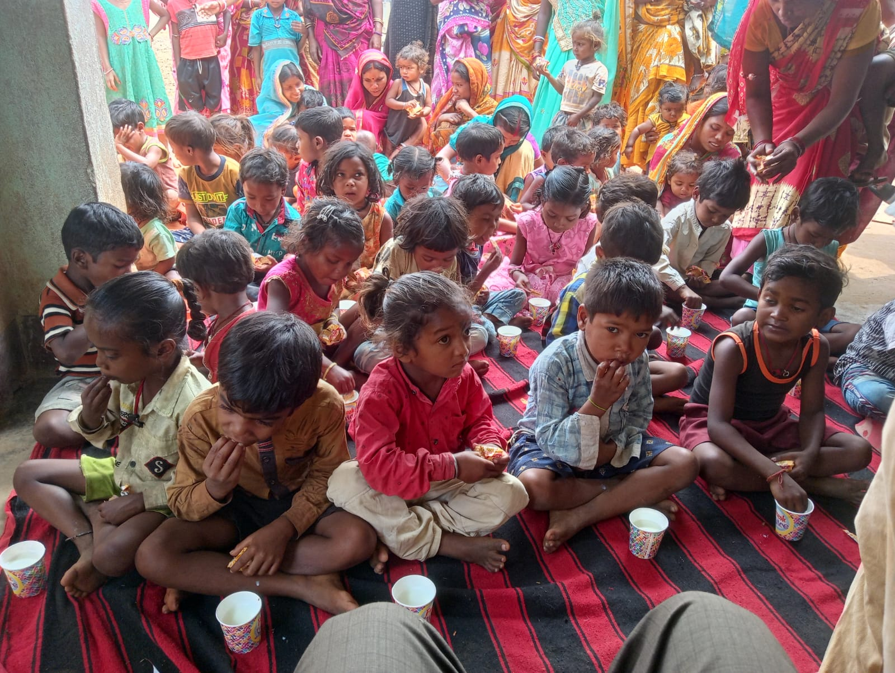
Women Panchayat level Organization Meeting. | Distribution Milk and Biscuit to 8 month to 5 years Child for nutritional purpose.

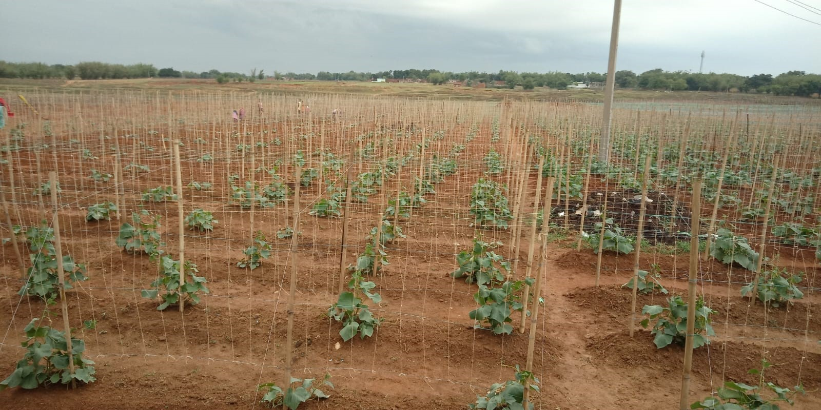 | 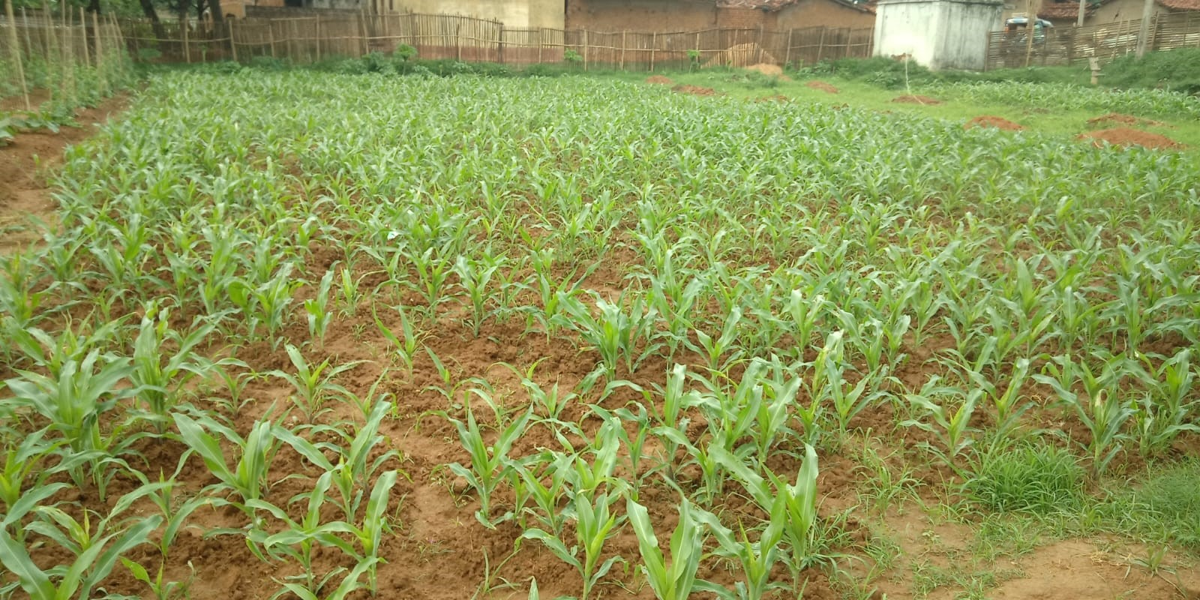
Improved Agricultural Practice

